EXAMPLE 3.21 From the samples x1(n) in Example 3.19a, reconstruct xa(t) and comment on the results.

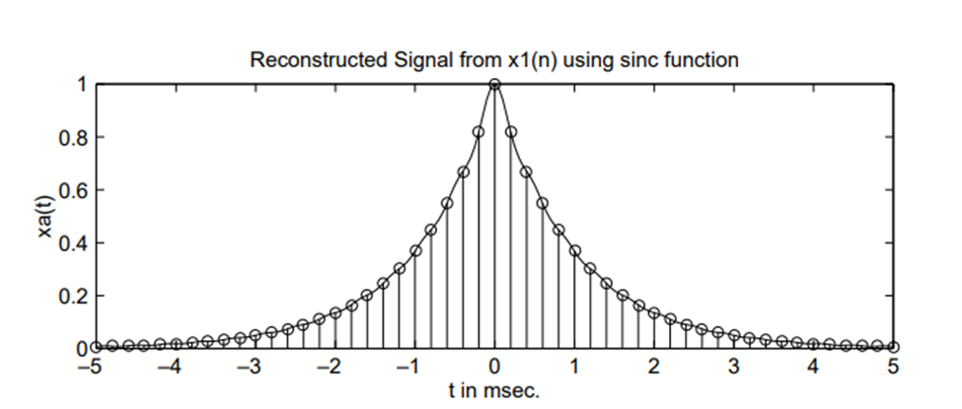

MATLAB script:

% Discrete-time Signal x1(n)

>> Ts = 0.0002; n = -25:1:25; nTs = n\*Ts; x = exp(-1000\*abs(nTs));

% Analog Signal reconstruction

>> Dt = 0.00005; t = -0.005:Dt:0.005; >> xa=x\* sinc(Fs\*(ones(length(n),1)\*t-nTs’\*ones(1,length(t))));

% check >> error = max(abs(xa - exp(-1000\*abs(t))))

error = 0.0363

Explanation:

* Because xa(t) is not strictly band-limited its maximum error in between is 0.0363.

EXAMPLE 3.22 From the samples x2(n) in Example 3.17b reconstruct xa(t) and comment on the results.

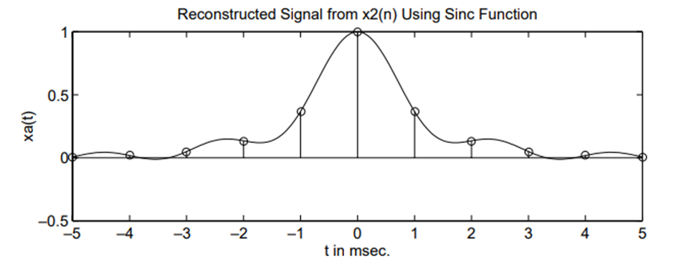

Matlab:

% Discrete-time Signal x2(n)

>> Ts = 0.001; n = -5:1:5; nTs = n\*Ts; x = exp(-1000\*abs(nTs));

% Analog Signal reconstruction >>

Dt = 0.00005; t = -0.005:Dt:0.005; >> xa=x\* sinc(Fs\*(ones(length(n),1)\*t-nTs’\*ones(1,length(t))));

% check >> error = max(abs(xa - exp(-1000\*abs(t))))

error = 0.1852

Explanation:

* The reconstructed signal changes over the interpolated regions as seen in the time domain. Since it is significant to the non-band limitedness of xa(t), the maximum error in between would be 0.1852.